Latihan ke – 2

- jalanin consul

dedi@dedi-HP-Notebook:~/Tugas/praxis-academy/novice/03-03/latihan/latihanMicronautGroovyKotlinJava/gradle$ **sudo docker run -p 8500:8500 consul**

[sudo] password for dedi:

==> Starting Consul agent...

Version: 'v1.6.2'

Node ID: 'd6b525cc-779e-cb61-4bc2-04bd440eb668'

Node name: 'd1dd93da71bd'

Datacenter: 'dc1' (Segment: '<all>')

Server: true (Bootstrap: false)

Client Addr: [0.0.0.0] (HTTP: 8500, HTTPS: -1, gRPC: 8502, DNS: 8600)

Cluster Addr: 127.0.0.1 (LAN: 8301, WAN: 8302)

Encrypt: Gossip: false, TLS-Outgoing: false, TLS-Incoming: false, Auto-Encrypt-TLS: false

==> Log data will now stream in as it occurs:

----------------------------------------------------------------

Jalanin multiple project build dari Groovy, Kotlin dan Java

dedi@dedi-HP-Notebook:~/Tugas/praxis-academy/novice/03-03/latihan/latihanMicronautGroovyKotlinJava/gradle**$ gradle -parallel run**

> Task :**gateway:run**

15:10:05.654 [main] INFO io.micronaut.runtime.Micronaut - Startup completed in 3944ms. Server Running: **http://localhost:8080**

15:10:05.979 [nioEventLoopGroup-1-2] INFO i.m.d.registration.AutoRegistration - Registered service [**gateway**] with Consul

> Task :**books:run**

15:10:05.662 [main] INFO io.micronaut.runtime.Micronaut - Startup completed in 3898ms. Server **Running: http://localhost:8082**

15:10:05.889 [nioEventLoopGroup-1-2] INFO i.m.d.registration.AutoRegistration - **Registered service [books] with Consul**

> Task :**inventory:run**

15:10:05.734 [main] INFO io.micronaut.runtime.Micronaut - Startup completed in 2864ms. Server **Running: http://localhost:8081**

15:10:06.139 [nioEventLoopGroup-1-2] INFO i.m.d.registration.AutoRegistration - Registered service [**inventory**] with Consul

<==========---> 81% EXECUTING [38m 54s]

> :gateway:run

Tampilan Consul :

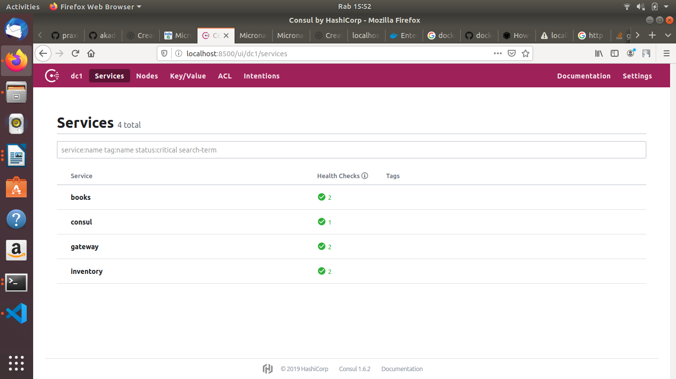

Mencoba Gateway : lewat 8080/api/books

Dari Gateway (Java), akan ke Books (Groovy). Yaitu untuk GET → api/books

data dari Books (Groovy),

class BooksRepositoryImpl

new Book("1491950358", "Building Microservices"),

new Book("1680502395", "Release It!"),

